**Grove - Screw Terminal**

窗体顶端

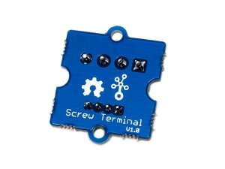

http://www.seeedstudio.com/depot/includes/templates/pure_green/images/next_l.gif

* [http://www.seeedstudio.com/depot/bmz_cache/b/bf80f83c235739952037d0d8ef9ea351.image.55x41.jpg](http://www.seeedstudio.com/depot/images/product/grter.jpg)
* [http://www.seeedstudio.com/depot/bmz_cache/0/0cd2e7b81002397d3c72cd93aa26e450.image.55x41.jpg](http://www.seeedstudio.com/depot/images/product/grter_01.jpg)

http://www.seeedstudio.com/depot/includes/templates/pure_green/images/next_r.gif

* **Price:**

$2.95  [(Price Feedback)](javascript:void())

* **SKU:**

COM12533P

* **Weight:**

5Gram

* **Units in Stock**

47

* **Designed by:**

[Seeed Studio](http://www.seeedstudio.com/)



[Other products from designer](http://www.seeedstudio.com/depot/seeed-studio-m-23.html)

* **Quantity:** Max: 47  
  
* [Add to Wish List](http://www.seeedstudio.com/depot/index.php?main_page=un_wishlist&products_id=996&cPath=156_158&action=un_add_wishlist)

Description

Grove - Screw Terminal with four 3.5mm pitch pins rate up to 125V @ 6A. Terminal can accept 30 to 20AWG wire. It is most common pitch screw terminal. This grove has four ports, include GND, VCC and two other undefined ports. Screw terminals are commonly used to connect a chassis ground, such as on a record player or surge protector. Most public address systems in buildings also use them for speakers, and sometimes for other outputs and inputs.

**Features**

* 3.5mm pitch pin
* Rated up to 125V @ 6A
* Accept 30 to 20AWG wire

**Documents**

Please visit our [wiki page](http://www.seeedstudio.com/wiki/Grove_-_Screw_Terminal) for more info about this product. It will be appreciated if  you can help us improve the documents, add more demo code or tutorials. For technical support, please post your questions to our forum.

窗体底端